**Nutrional Analysis of Popular Indian Foods using Tableau**

**Problem Statement:**

In light of the growing emphasis on health and wellness, ABC Company recognizes the need to provide tailored dietary recommendations to its customers, particularly those seeking guidance on Indian cuisine. However, existing dietary advice often lacks specificity and relevance to regional dietary practices. To address this gap, ABC Company aims to develop a robust diet recommendation system based on Indian Recommended Dietary Allowances (RDA). By leveraging data on the nutritional composition of various Indian food items, including total calories, proteins, fats, and fiber, ABC Company seeks to create personalized diet plans that align with RDA guidelines. The challenge lies in designing an intuitive and user-friendly system that effectively translates nutritional data into actionable dietary recommendations, ultimately empowering customers to make informed choices for their health and well-being.

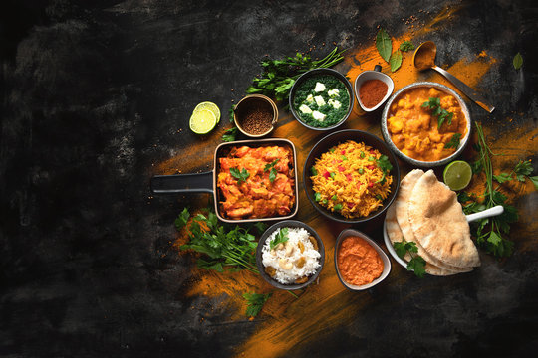

**Prerequisites:**

* Basic understanding of Data Analytics

[What Is Data Analytics? - An Introduction (Full Guide)](https://youtu.be/yZvFH7B6gKI?si=jD37tQzKJH1vl56A)

* Awareness of the lifecycle of a Data Analytics Project

[A Beginners Guide To The Data Analysis Process](https://youtu.be/lgCNTuLBMK4?si=a_J79oNSQIGNuNlH)

* Understand Tableau Interface- [Link](https://www.youtube.com/watch?v=oIw8xJ1Fy3w)
* Download Tableau Desktop-[Link](https://www.tableau.com/products/desktop/download)

**Objective:**

An objective is a specific, measurable, and time-bound goal or target that an individual or organization aims to achieve. Objectives are typically set to guide actions and decision-making towards desired outcomes. They are often a part of broader goals and help to clarify what needs to be accomplished within a certain timeframe. Objectives should be realistic, achievable, and relevant to the overall mission or purpose, providing a clear direction for efforts and resources.

**Task:**

* Analyse the nutritional composition: Evaluate the total calories , carbs , sugars , proteins, fats, and fiber content of various Indian food items to gain a comprehensive understanding of their nutritional profile.
* Assess alignment with RDA guidelines: Compare the nutritional data of Indian dishes with Recommended Dietary Allowances (RDA) to identify areas where dietary practices may deviate from established guidelines, aiming to ensure that diet recommendations are in line with nutritional standards.
* Develop personalized diet recommendations: Utilize the analysed data and RDA guidelines to create tailored diet plans for individuals, presenting them in an easily understandable format to empower users to make informed decisions about their dietary habits.

**Dataset**: [Link](https://www.kaggle.com/datasets/tarunrm09/indian-cuisine-based-rda-diet-recommendation-data)

**Solution Development Procedure:**

* In Tableau, the "Connect" option refers to the initial step in the data visualization process where users connect to various data sources to import data into Tableau for analysis and visualization.

* When you select the "Connect" option in Tableau, you are presented with a variety of data connection options.



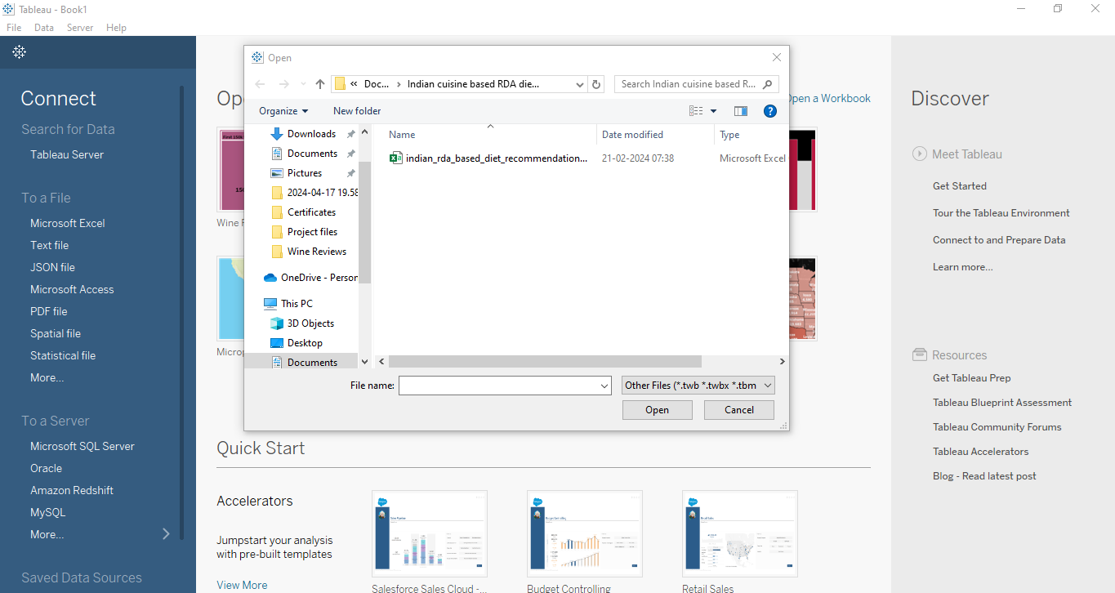

* Once we load the data into the Tableau.

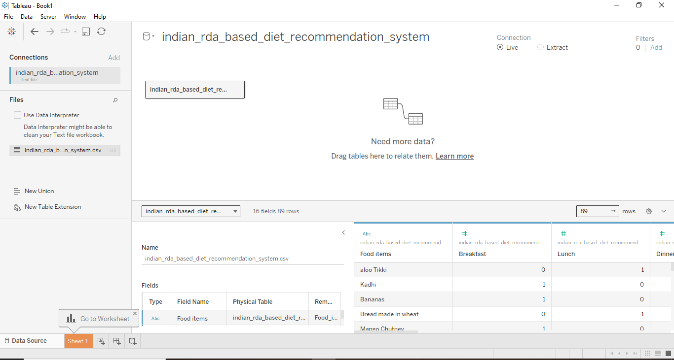

* Now , we proceed to create dashboard for Indian RDA Diet Insights.
* To create the dashboard, which will satisfy the task above, we consider the followingcolumns:
  + Count of Food items
  + Total Carbohydrates in Food Items
  + Total Sugars in Food items
  + Total Fats in Food Items
  + Total Fibre in Food Items
  + Total Calories by Food Items
  + Total Protein by Food Items
* We have created the dashboard which is presented below.

**Dashboard:**

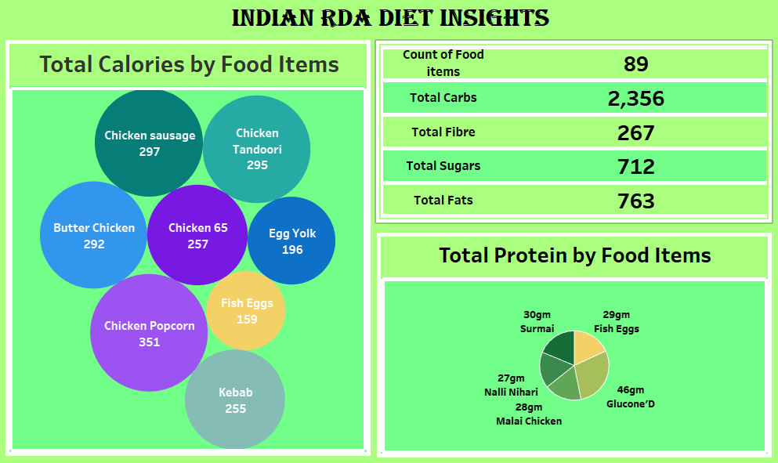

**Explanation Video:** Link

Note: The explanation video for the dashboard is in the link above.

**Insights:**

Insights refer to valuable and meaningful understandings or perceptions gained from analysing data, information, or experiences. They provide deeper understanding, clarity, or revelation regarding a particular subject or situation.

* The dashboard reveals the caloric content of various food items, with Chicken Popcorn standing out with the highest calorie count at 351. This information underscores the importance of being mindful of calorie intake when making food choices to maintain a balanced diet and manage weight effectively.
* The breakdown of essential nutrients shows significant quantities of carbohydrates, fiber, sugars, and fats among the 89 food items considered. This highlights the need for a diet that encompasses a variety of nutrient sources to meet daily nutritional requirements adequately.
* The pie chart on protein content highlights specific foods rich in protein, including Surmai, Fish Eggs, Nalli Nihari, Malai Chicken, and Glucone’D. This emphasizes the importance of incorporating both vegetarian and non-vegetarian protein sources into one's diet to ensure adequate protein intake, supporting muscle growth, repair, and overall health.

**Conclusions :**

Conclusions are logical deductions or decisions drawn from observations, evidence, or analysis. Conclusions are often based on the findings or results of a study, experiment, or evaluation, and they aim to summarize key insights or outcomes. Effective conclusions should be supported by evidence, logical reasoning, and critical thinking, leading to well-informed decisions or actions.

* The analysis of Indian cuisine-based RDA diet recommendations offers valuable insights into caloric distribution, nutrient composition, and protein sources. This enables individuals to make informed decisions about their food choices, aligning with RDA guidelines for optimal nutrition.
* The breakdown of nutrients across 89 food items highlights the importance of diversifying one's diet to ensure a balanced intake of essential nutrients. This diversity is crucial for meeting daily dietary requirements and promoting overall health and well-being.
* Emphasizing the significance of incorporating both vegetarian and non-vegetarian protein sources underscores the importance of a personalized approach to diet planning. Tailoring dietary choices to individual preferences and nutritional needs can lead to more sustainable and effective health outcomes, empowering individuals to achieve their wellness goals.